**DATA BACKUP AND RESTORING USING RPA**

**PROBLEM DESCRIPTION**

Data backup is the process of backing up the data, refers to copying the data into an archive file of computer data so it may be used to restore the original after a data loss event. Backups have two distinct purposes. The primary purpose is to recover data after its loss, it can be data deletion or corruption. Data loss can be a common experience of computer users while transferring the data.

The secondary purpose of backups is to recover data from an earlier time, according to a user-defined data retention policy, typically configured within a backup application for how long copies of data are required.These processes can be fully automated with the RPA solutions by providing them with the required credentials, source and destination details for the whole task to be automated.

**INTRODUCTION**

In our proposed system, the data from the different sources are collected on a daily basis. The bot will be trained to the process of extraction of data based on condition. The process will be idle until the admin triggers the bot using the UiPath Orchestrator. After the triggering factor, the files from the different sources are collected as a master file. The backup process is done for the master file. It is done on daily basis. The restoring process will be done on monthly basis. The front end process is developed using the UiPath studio and the back end process is done through the Orchestrator.

**TECHNOLOGY TO BE USED:**

RPA-UiPath tool

**MODULE SPLITUP:**

Module 1: Separating the data from the data set  
Module 2: Orchestrator connection  
Module 3: Backup process  
Module 4: Restoring connection

**INPUT FILE**

The input file is received from the mail and it will read the data. Based on the condition, certain data gets separated from the whole data set and the backup process will be performed for the separated data. The data gets stored in the Orchestrator and it will generate the output in the form of excel sheet.

**SYSTEM REQUIREMENTS**

**Software Interface**

**Operating system :** Windows 10

**IDE :** UiPath Studio

**Hardware Interface**

**Processor :** Intel®core™i3-6006U CPU @ 2.00GHz 2.00GHz

**Memory :** 4.00 GB RAM

**Communication Interface :** Windows

**OUTPUT FILE**

Once the data backup process gets completed, the restoring process will be executed. In our system, the restoring process will be done on monthly basis and it will generate an excel sheet which consists of the restored data.

**SCREENSHOTS**

1. The initial data set which consists of several data.

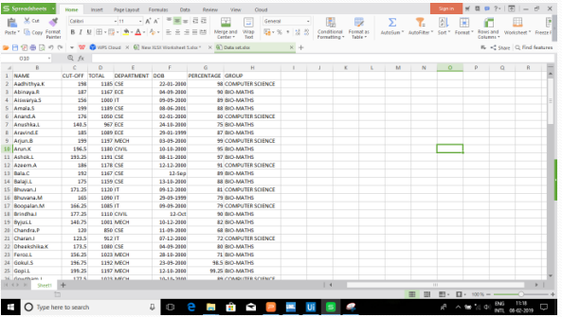

2)Workflow for receiving the input from the mail. 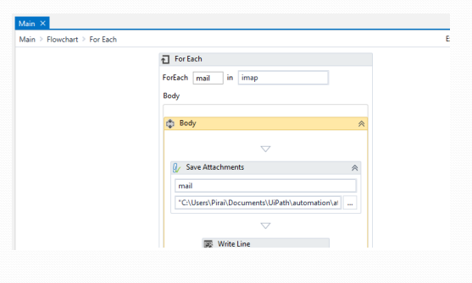

3)Workflow for the backup process.

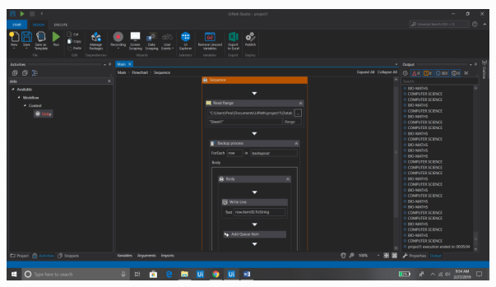

1. This is the orchestrator connection.ie, the robot has been connected to the orchestrator.

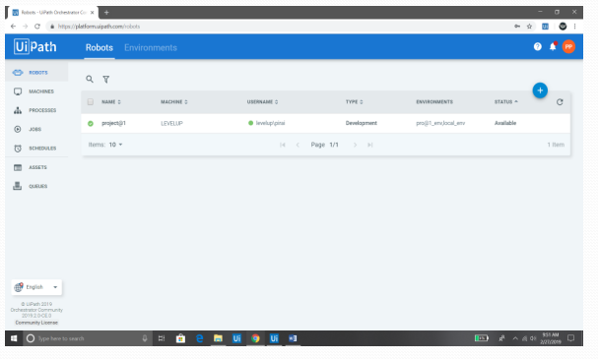

1. This is the output of the backup process. The download symbol in the screen indicates that the file can be downloaded which is the output file.

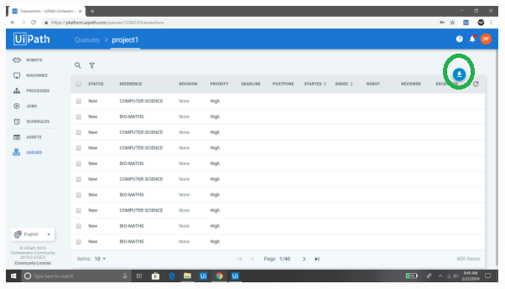

**CONCLUSION**

The main aim of this project is to improve the speed of the data backup and the restoring process. The key idea we have applied here is the automation. Automation we have applied does not require any manual work in order to manage the data during the process. It supports large volume of data and because of the automation process, the performance of the system does not affected by the internal process. It requires only short time for the whole automation process which is very much beneficial when compared to the manual process. The security is enhanced so that the data cannot be lost during the process. The inter operability speed of the system gets improved by our proposed system.